SIMATS ENGINEERING
ASSESSMENT TOOL 1: Analytical Problem Solving

COURSE NAME: Cloud Computing and Big Data Analytics
COURSE CODE: CSA1513

Name: Ashwika S Register No: 1924260248

COURSE OUTCOME COVERED

CO2: Analyse virtualization architectures to identify performance and security issues in cloud computing environments. (BL3)
Dave's Taxonomy: Manipulation (Level 2)
Question Count: 5
Total Marks: 50
Duration : 60 Minutes

Code of Conduct
I Ashwika S (1924260248) certify that this submission is my original work and that I have adhered to the guidelines specified for this assessment.
I understand that any violation of academic integrity rules will result in disciplinary action.
Signature of the student: Ashwika S

Assessment Tasks

Analytical Problem Solving
1. Compare Type-1 and Type-2 hypervisors for a cloud data centre hosting mission-critical applications. Analyse performance, security, and manageability, then justify the better choice.
2. A cloud provider must isolate workloads belonging to finance, healthcare, and student portals on the same hardware. Analyse how virtualization architecture supports isolation and identify two major attack surfaces.
3. Study the following VM host utilization snapshot and recommend corrective actions: CPU 92%, memory 88%, storage I/O latency 35 m s, average VM boot time 170 s. Explain the likely bottlenecks.
4. Analyse how Software Defined Datacentre architecture improves agility compared with a traditional datacentre. Support your answer with compute, storage, and network virtualization considerations.
5. A multi-cloud federation project fails due to identity mismatches between providers. Analyz se the issue and propose a secure identity and privacy design using federation concepts.
Equivalent Steps in VMware Workstation Pro
- Library pane showing multiple VMs = multiple instances/regions.
- VM → Snapshot → Take Snapshot, then Snapshot Manager = backup/versioning demonstration.
- Edit → Virtual Network Editor to show NAT/Host-only/Bridged networks = hybrid or multi-cloud connectivity.
- VM → Manage → Clone = replica/auto-scaling demonstration.
Tip: Paste each screenshot directly under the relevant question in this document (Insert → Picture in Word) before final submission, with a one-line caption explaining what it demonstrates.

ANSWERS
Name: Ashwika S Register No: 1924260248 Course: CSA15 – Cloud Computing and Big Data Analytics
Question 1. Compare Type-1 and Type-2 hypervisors for a cloud datacentre hosting mission-critical applications. Analyse performance, security, and manageability, then justify the better choice.

Analysis: A hypervisor is the software layer that creates and runs virtual machines. A Type-1 (bare-metal) hypervisor installs directly on the server hardware (VMware ESXi, Microsoft Hyper-V, KVM, Xen). A Type-2 (hosted) hypervisor runs as an application on top of a host operating system (VMware Workstation, VirtualBox).
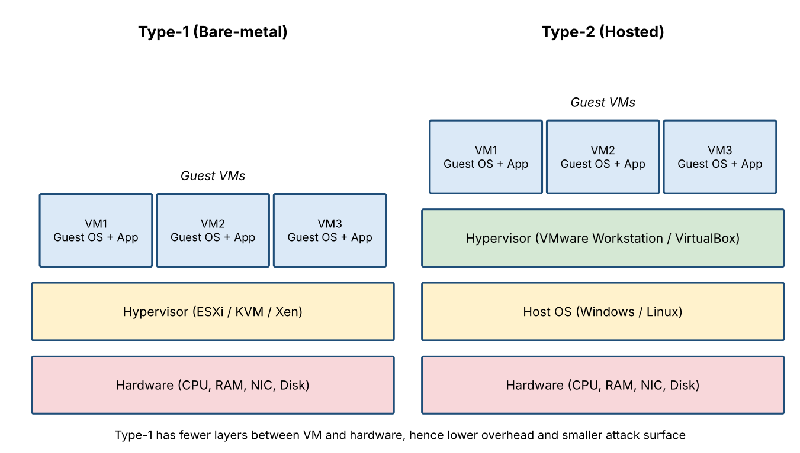
Figure 1: Layered architecture of Type-1 (bare-metal) and Type-2 (hosted) hypervisors
Criteria | Type-1 (Bare-metal) | Type-2 (Hosted)
Architecture | Runs directly on hardware; hypervisor is the OS | Runs on a host OS; VMs reach hardware through the host OS
Performance | Near-native speed; direct access to CPU, memory, NIC and disk; low overhead; supports large consolidation ratios | Extra layer (host OS) adds latency and overhead; host OS processes compete for resources
Security | Small code base and attack surface; no general-purpose OS services; hardware-assisted isolation (VT-x/AMD-V, IOMMU) | Large attack surface: host OS vulnerabilities, malware and other apps can compromise all VMs
Manageability | Central management (vCenter, SCVMM, OpenStack); live migration, HA, DRS, clustering, automation by API | Manual, per-machine management; no HA or live migration at scale
Reliability | High availability and fault tolerance; host OS crash does not exist as a separate failure point | Host OS crash, patch or reboot stops every VM
Scalability | Scales to hundreds of hosts and thousands of VMs | Limited to a single desktop or workstation
Typical use | Cloud datacenters, production servers, mission-critical workloads | Testing, development, training, desktop labs
Cost | Needs supported server hardware and licences, lower cost per VM at scale | Cheap and easy for single users, costly at scale

Justification: For a cloud datacentre hosting mission-critical applications, the Type-1 hypervisor is the better choice. It gives higher performance and predictable latency, a smaller attack surface, strong tenant isolation, and enterprise features such as live migration, high availability, resource scheduling and centralized monitoring. These features keep service level agreements (SLAs) satisfied even when a host fails or needs maintenance. Type-2 hypervisors are suitable only for testing, development and learning.

Conclusion: Type-1 hypervisor is selected.

VMware Workstation equivalent: Library pane with several VMs shown as multiple instances (screenshot to be pasted here). Caption: Multiple VMs running in the Library pane representing separate cloud instances.

Question 2. A cloud provider must isolate workloads belonging to finance, healthcare, and student portals on the same hardware. Analyze how virtualization architecture supports isolation and identify two major attack surfaces.
Analysis: Finance, healthcare and student portal workloads are hosted as separate virtual machines (or containers) on the same physical servers. Virtualization provides isolation through the following mechanisms:
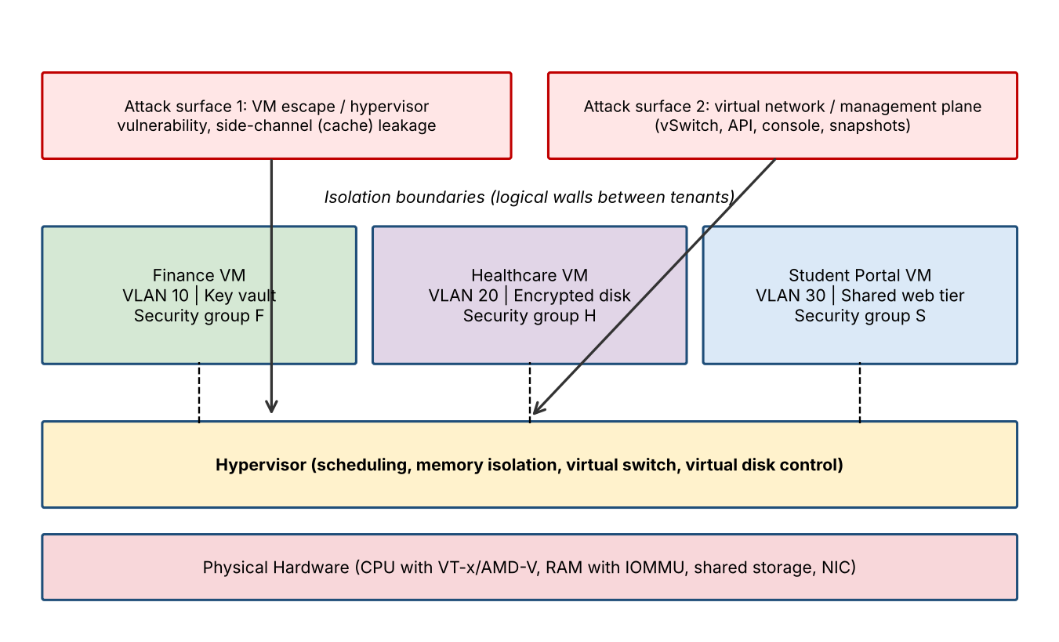
Figure 2: Multi-tenant isolation of finance, healthcare and student portal VMs, with two major attack surfaces
Isolation layer | How it supports isolation
CPU and memory | The hypervisor schedules vCPUs separately and uses hardware-assisted virtualization (Intel VT-x / AMD-V) and nested page tables (EPT/NPT), so one VM cannot read another VM's memory
Device and I/O | IOMMU (VT-d) and virtual devices give each VM its own virtual NIC and disk; there is no direct shared access
Storage | Separate virtual disks and datastores or LUNs; encryption at rest with per-tenant keys (important for healthcare and finance data)
Network | Separate VLANs or VXLAN overlay segments, virtual switches, firewalls and security groups per tenant; micro-segmentation blocks east-west traffic
Management / access | Role-based access control, separate admin domains, audit logging; placement rules (anti-affinity) keep sensitive workloads on dedicated hosts or clusters
Compliance | Healthcare data follows HIPAA-type rules and finance data follows PCI-DSS-type rules, so these get stricter isolation than the student portal

Two major attack surfaces:
Attack surface | Description | Mitigation
1. Hypervisor / VM escape and side-channel attacks | A bug in the hypervisor or in a virtual device lets a malicious VM break out and control the host or read other tenants' memory; shared CPU caches allow side-channel leakage (for example Spectre-class attacks) | Patch hypervisor regularly, minimal hypervisor footprint, disable unused virtual devices, dedicated hosts for sensitive tenants, memory and CPU isolation features, secure boot
2. Virtual network and management plane | Compromised vSwitch, VLAN hopping, weak API or management console credentials, unprotected snapshots and VM images give access to many tenants at once | Network micro-segmentation, separate management network, MFA and RBAC for admins, API authentication, encrypted snapshots and images, logging with SIEM

Conclusion: Virtualization isolates the three workloads logically on shared hardware. Because the hypervisor and management plane are shared by everyone, they are the two critical attack surfaces and must be hardened, monitored and patched.

VMware Workstation equivalent: Edit → Virtual Network Editor with separate Host-only networks per workload (screenshot to be pasted here). Caption: Separate virtual networks isolating each workload.

Question 3. Study the following VM host utilization snapshot and recommend corrective actions: CPU 92%, memory 88%, storage I/O latency 35 ms, average VM boot time 170 s. Explain the likely bottlenecks.
Analysis of the snapshot: The table compares each observed metric with a commonly accepted healthy limit.
Metric | Observed | Healthy range | Interpretation
CPU utilization | 92% | below 70–80% | Near saturation; high CPU ready time and vCPU contention, so VMs wait for CPU
Memory utilization | 88% | below 75–80% | Memory pressure; risk of ballooning, swapping and page faults
Storage I/O latency | 35 ms | below 10–20 ms | Slow storage; queues build up and disk reads are delayed
Average VM boot time | 170 s | about 30–60 s | Symptom of the three issues above, worsened by boot storms
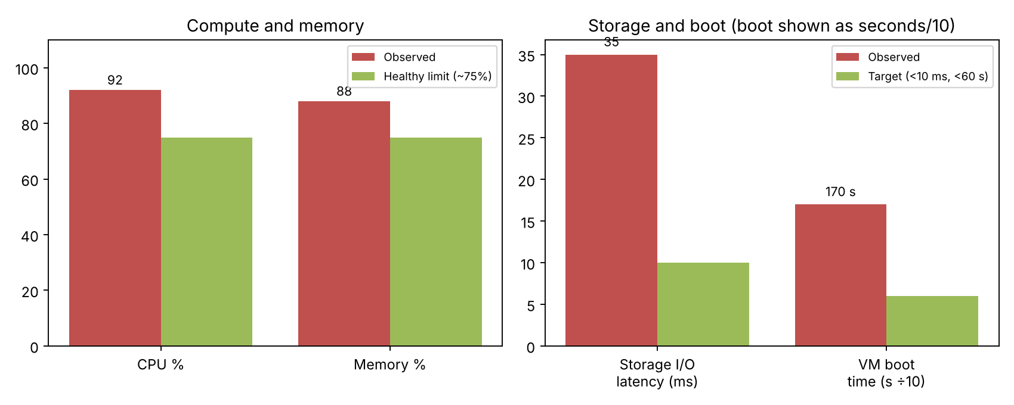
Figure 3: Observed host utilization compared with healthy limits
Likely bottlenecks:
- CPU contention: The host is over-committed (too many vCPUs per physical core), so VMs queue for CPU time.
- Memory pressure: High memory use causes ballooning and swapping to disk, which adds extra I/O on an already slow storage system.
- Storage I/O bottleneck (primary): 35 ms latency points to a shared or overloaded datastore, an under-provisioned disk tier (HDD instead of SSD), or a congested storage network.
- Boot storm: A VM boot reads the OS image and writes logs and swap. When many VMs start together, the disk and CPU saturate and boot time increases to 170 s.
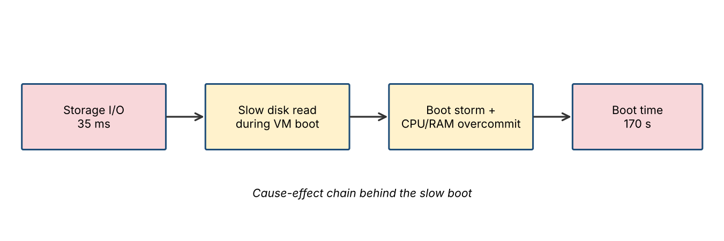
Figure 4: Cause and effect chain leading to slow VM boot
Corrective actions:
Area | Recommended action
CPU | Live-migrate (vMotion/DRS) some VMs to lighter hosts; right-size vCPUs; reduce the vCPU-to-core ratio; add hosts to the cluster (scale out)
Memory | Remove idle memory, right-size VM memory, enable memory compression, add RAM or move VMs to other hosts; avoid excess overcommit
Storage | Move hot VMs to SSD/NVMe tier, enable caching and storage tiering, balance datastores (Storage DRS), use thin clones or linked clones, tune queue depth and multipathing
Boot time | Stagger boot schedule, use VM templates and clones, keep golden images on SSD, pre-warm or use auto-scaling pools
Monitoring | Set alerts at 80% CPU/memory and 20 ms latency; track CPU ready, ballooning and datastore latency; capacity planning

Conclusion: The host is overloaded in CPU and memory, and storage latency is the main bottleneck behind the slow boot time. Load balancing, right-sizing and faster storage should reduce utilization below 75%, latency below 10 ms and boot time near 60 s.
VMware Workstation equivalent: Snapshot Manager / Task Manager showing resource usage (screenshot to be pasted here). Caption: Resource utilization of the host with running VMs.

Question 4. Analyse how Software Defined Datacentre architecture improves agility compared with a traditional datacentre. Support your answer with compute, storage, and network virtualization considerations.
Analysis: A Software Defined Datacentre (SDDC) virtualizes and abstracts compute, storage and networking, and controls all of them through software and policies with automation. In a traditional datacentre, each of these is tied to specific hardware and configured manually, so changes are slow.
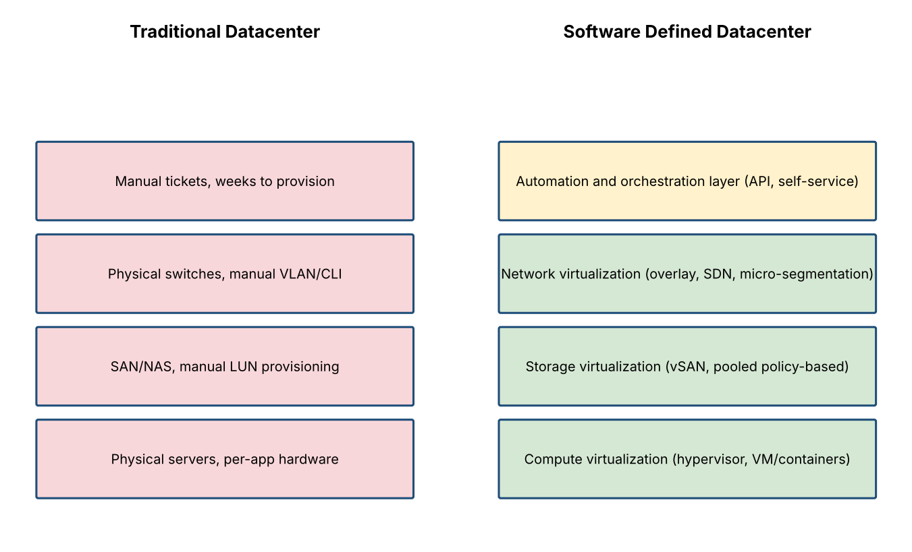
Figure 5: Traditional datacentre compared with Software Defined Datacentre layers
Aspect | Traditional datacentre | Software Defined Datacentre
Compute | Dedicated physical server per application; low utilization (10–20%) | Hypervisor and containers pool CPU and RAM; VMs created in minutes; 60–80% utilization
Storage | SAN/NAS with manual LUN creation and zoning | Storage virtualization (vSAN, Ceph) pools disks; policy-based provisioning and automatic tiering
Network | Physical switches configured one by one using CLI | Network virtualization and SDN with overlay (VXLAN), virtual routers, firewalls and micro-segmentation configured by software
Provisioning time | Days to weeks (tickets, procurement, cabling) | Minutes through self-service portal and API
Scaling | Buy and install hardware; over-provision for peak | Elastic scale-out and auto-scaling on commodity hardware
Management | Siloed teams, manual, error-prone | Single orchestration layer, automation, Infrastructure as Code
Availability / DR | Manual failover, hardware dependent | Live migration, HA, replication and snapshots handled by software
Cost | High CAPEX, low utilization | Lower CAPEX and OPEX, pay-per-use possible

How agility improves:
- Faster provisioning: Resources come from shared pools, so a new environment is ready in minutes rather than weeks.
- Automation and consistency: Policies and templates cut human error and ensure consistent configuration across the datacenter.
- Elasticity: Workloads can be scaled up or down as demand changes without rewiring hardware.
- Policy-driven networking and storage: Network and storage changes are made through software, so new tenants or applications are isolated instantly.
- Faster innovation: Application and infrastructure changes follow DevOps pipelines, shortening release cycles.
Conclusion: SDDC makes infrastructure programmable, so it is far more agile, efficient and scalable than the traditional datacentre.

VMware Workstation equivalent: VM → Manage → Clone to create replicas quickly (screenshot to be pasted here). Caption: Cloning a VM to demonstrate rapid provisioning and scaling.

Question 5. A multi-cloud federation project fails due to identity mismatches between providers. Analyse the issue and propose a secure identity and privacy design using federation concepts.
Problem analysis: In a multi-cloud setup every provider has its own identity system (for example AWS IAM, Azure AD / Entra ID, a private LDAP). The same user may have different usernames, attribute names, roles, token formats and authentication protocols in each cloud. This identity mismatch causes failed logins, wrong or missing permissions, duplicate accounts, inconsistent de-provisioning, and privacy risk when too many attributes are copied between providers.
Cause of mismatch | Effect on federation
Different identifiers (email vs. UPN vs. employee ID) | Same user not recognised; duplicate accounts
Different protocols (SAML, OIDC, Kerberos, proprietary) | Token not accepted by the other provider
Different attribute and role schemas | Authorization errors or excess privileges
No common trust between providers | Federation fails or needs manual credentials
Unsynchronised user life cycle | Orphan accounts remain after a user leaves
Excess attribute sharing | Privacy and compliance violations

Proposed secure identity and privacy design (federated identity):
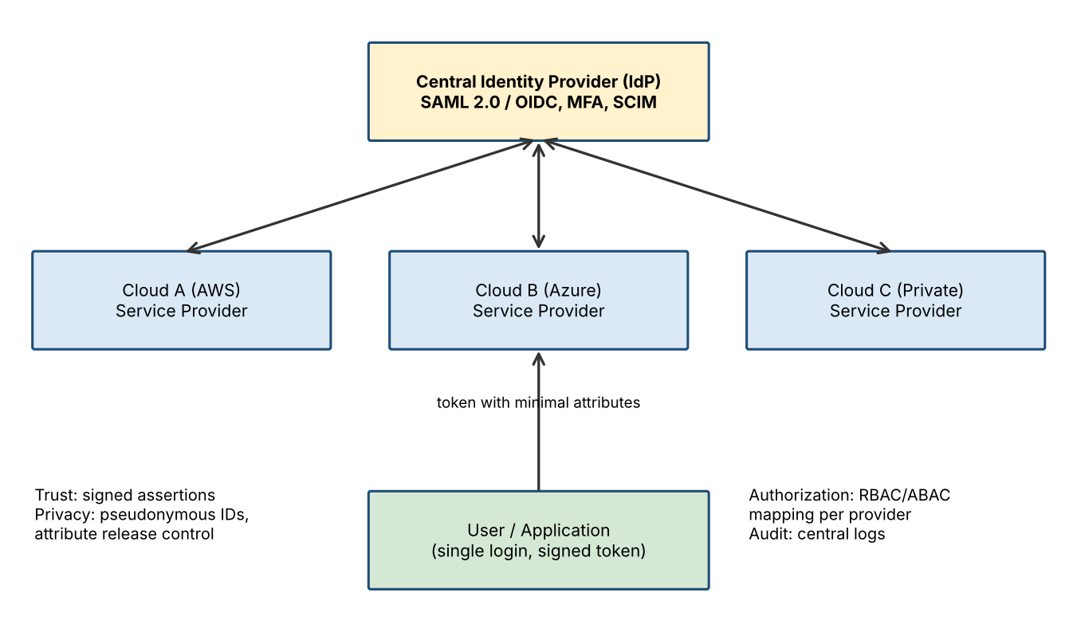
Figure 6: Federated identity architecture across multiple clouds using a central IdP
Design element | Description
Federated trust | Establish trust between a central Identity Provider (IdP) and each cloud (Service Provider) using metadata and certificates; use SAML 2.0 or OpenID Connect / OAuth 2.0 standards
Single Sign-On (SSO) | User authenticates once at the IdP and receives a signed, time-limited token accepted by all clouds
Common identity mapping | A unique immutable ID per user; attribute mapping and claim transformation rules between provider schemas
Provisioning | SCIM for automatic creation, update and removal of accounts so no orphan accounts remain
Authorization | Role-based / attribute-based access control (RBAC/ABAC) mapped to a common role model; least privilege
Strong authentication | Multi-factor authentication, conditional access, short token lifetime and token signing and encryption (TLS)
Privacy | Share only minimal attributes (data minimisation); pseudonymous or pairwise identifiers per provider; user consent for attribute release; encryption of personal data; compliance with GDPR and similar laws
Audit and monitoring | Central logging of authentication events, anomaly detection, periodic access reviews

Login flow: 1) User requests a service in Cloud B. 2) Cloud B redirects the user to the central IdP. 3) IdP authenticates the user with MFA. 4) IdP issues a signed token with minimal attributes. 5) Cloud B validates the signature, maps the roles and grants access. 6) The event is logged centrally.

Conclusion: A standards-based federated identity design with a central IdP, SSO, attribute mapping, automated provisioning, MFA and data minimisation removes the identity mismatch while protecting privacy and security.

VMware Workstation equivalent: Virtual Network Editor showing NAT / Host-only / Bridged networks for hybrid connectivity (screenshot to be pasted here). Caption: Different network types connecting separate environments.

Analytical Problem Solving Rubric
Criteria | Weightage | Level 4 - Exemplary | Level 3 – Proficient | Level 2 - Developing | Level 1 - Beginning
Problem Interpretation | 20% | Interprets all technical requirements accurately | Interprets most requirements correctly | Partial interpretation | Misinterprets the problem
Analytical Reasoning | 25% | Strong reasoning with clear cause-effect analysis | Good reasoning with minor gaps | Basic analysis only | Weak or no analysis
Method Selection | 20% | Chooses highly appropriate virtualization and security concepts | Chooses mostly suitable concepts | Partially suitable concepts | Inappropriate approach
Solution Quality | 20% | Provides feasible and technically sound solution | Reasonable solution with minor issues | Basic solution with limitations | Unclear or invalid solution
Presentation of Analysis | 15% | Well-structured and technically precise | Generally clear | Somewhat unclear | Difficult to follow
Total Marks Awarded:

